PROGRAM TO FIND THE ROOTS OF A QUADRATIC EQUATION

* PROGRAM

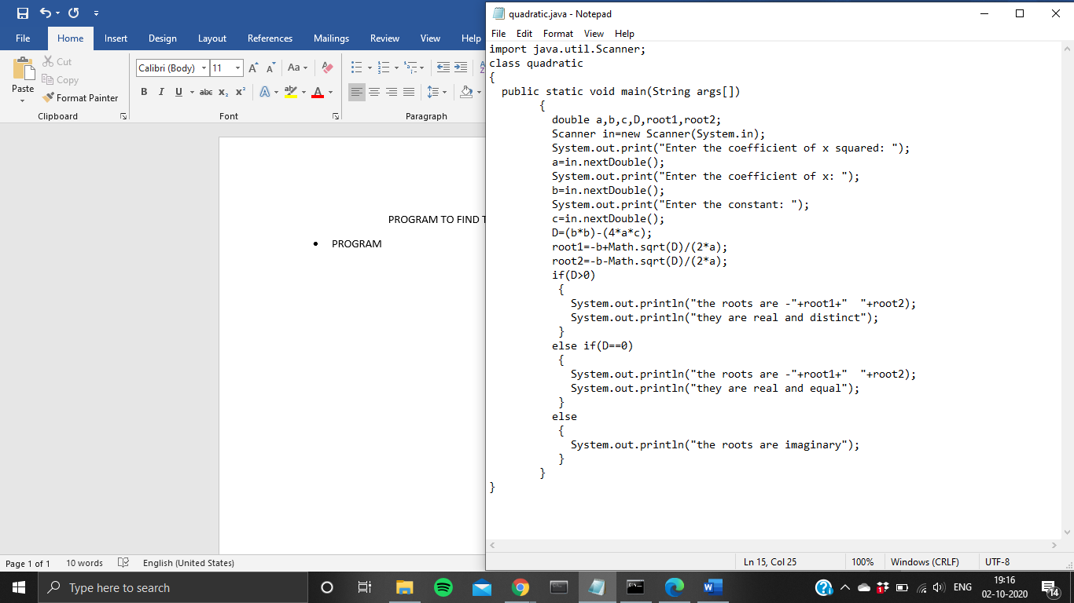

* OUTPUT

1. WHEN ROOTS ARE REAL AND DISTINCT

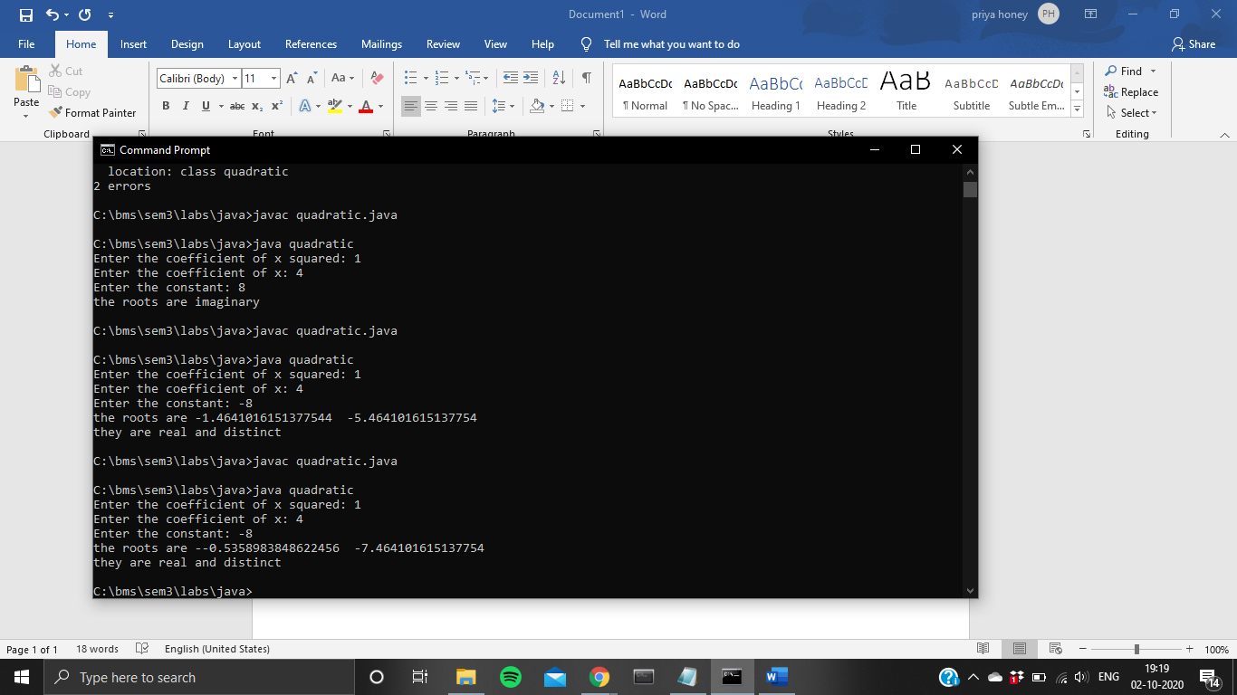

1. WHEN ROOTS ARE REAL AND EQUAL

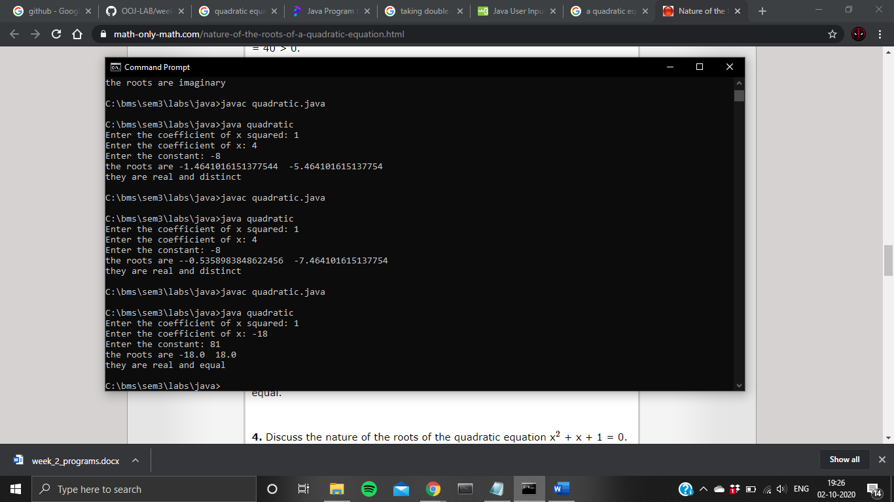

1. WHEN ROOTS ARE IMAGINARY

